Instagram History
You will create an INSTAGRAM profile complete with posts for the Greek philosophers we have discussed - Aristotle, Plato, and Socrates utilizing the powerpoint template.
Requirements:
- You are to create at least 6 Instagram-style posts using images or photos and captions complete with likes and comments that give additional information about the photo topic.
- To create 6 posts, you will make two posts per philosopher.
- Cover at least 2 areas of the philosophers beliefs with your photos and captions (You can use your notes or the chart below to guide you):
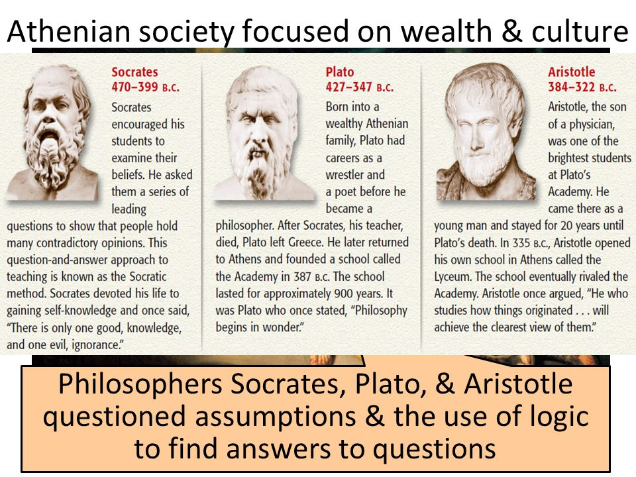
- The captions must be at least 2 sentences long and must explain the history of what is happening in the photo, not just tell what the photo is
- Use your own words. Do not take words from your resources.
- Include at least 2 comments for your photos.
- Use Internet resources to find other primary sources as needed.
- Try to come up with ideas that no one else will have. Be creative! Hash tagging is encouraged but not required.
- Write your captions using accurate, historical information.
- Post your completed photos and captions on a Powerpoint Presentation, with each photo being a slide. You should have a minimum of 6 slides (6 posts / two each philosopher).
- You will find an Instagram Template on my website www.mrweissworldhistory.weebly.com

You and your partner will be presenting your Instagram History on Friday, September 27th.

Rubric
 | 3 | 2 | 1
Photos | All 6 photos are included, from the philospher, and show a comprehensive understanding of their views. | 4 or 5 photos are included from your philosopher, and show a somewhat comprehensive history of the philosopher | Less than 4 photos are included and may or may not cover each philosopher. They fail to show a comprehensive history.
Captions | All 6 photos have comments that are at least 2 sentences in length, tell more than what is in the photograph, and include historically accurate information | 4 or 5 photos have comments. Most of the comments are at least 2 sentences in length, tell more than what is in the photograph, and includes mostly accurate information | Less than 4 photos have comments or many of the comments are less than 2 sentences in length. Sentences fail to describe more than what is in the picture, and/or information is incorrect.
Comments | 2 comments are included | 1 comments are included
Variety of Topics | At least 2 different topics are covered per phiosopher | At least 2 different topics are covered for 2 philosophers | Less than 3 topics are covered
Creativity | All captions, comments, names, hashtags, etc. are all relevant to the subject and are creative and unique | Most captions, comments, names, hashtags, etc. are all relevant to the subject and are creative and unique | Many of the captions, comments, names, hashtags, etc. are not relevant to the subject and are not creative and unique
Spelling and Grammar | There are no spelling/grammar errors seen or heard. | There are between 4-6 spelling and grammar errors. | There are more than 6 spelling and/or grammar errors.

Total Points___________ Grade__________

